Intermediate Code Generation

In the analysis-synthesis model of a compiler, the front end analyzes a source program
and creates an intermediate representation, from which the back end generates target
code. This facilitates retargeting: enables attaching a back end for the new machine to an
existing front end.
Logical Stucture of a Compiler Front End

A compiler front end is organized as in figure above, where parsing, static checking, and
intermediate-code generation are done sequentially; sometimes they can be combined and
folded into parsing. All schemes can be implemented by creating a syntax tree and then
walking the tree.
Static Checking
This includes type checking which ensures that operators are applied to compatible
operands. It also includes any syntactic checks that remain after parsing like

·
flow–of-control checks

–
Ex: Break statement within a loop construct

·

·
Uniqueness checks
– Labels in case statements
Name-related checks

Intermediate Representations
We could translate the source program directly into the target language. However, there
are benefits to having an intermediate, machine-independent representation.

·

·

·
A clear distinction between the machine-independent and machine-dependent
parts of the compiler
Retargeting is facilitated; the implementation of language processors for new
machines will require replacing only the back-end
We could apply machine independent code optimisation techniques

Intermediate representations span the gap between the source and target languages.

·
High Level Representations

–
–
–
closer to the source language
easy to generate from an input program
code optimizations may not be straightforward

·
Low Level Representations

–
–
closer to the target machine
Suitable for register allocation and instruction selection

1

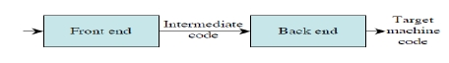

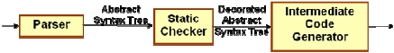

–

easier for optimizations, final code generation

There are several options for intermediate code. They can be either

·

·
Specific to the language being implemented
o P-code for Pascal
o Bytecode for Java
Language independent:

o 3-address code
IR can be either an actual language or a group of internal data structures that are shared
by the phases of the compiler. C used as intermediate language as it is flexible, compiles
into efficient machine code and its compilers are widely available.
In all cases, the intermediate code is a linearization of the syntax tree produced during
syntax and semantic analysis. It is formed by breaking down the tree structure into
sequential instructions, each of which is equivalent to a single, or small number of
machine instructions. Machine code can then be generated (access might be required to
symbol tables etc).
Syntax Trees

Syntax trees are high level IR. They depict the natural hierarchical structure of the source
program. Nodes represent constructs in source program and the children of a node
represent meaningful components of the construct. Syntax trees are suited for static type
checking.
Variants of Syntax Trees: DAG
A directed acyclic graph (DAG) for an expression identifies the common sub expressions
(sub expressions that occur more than once) of the expression. DAG's can be constructed
by using the same techniques that construct syntax trees.
A DAG has leaves corresponding to atomic operands and interior nodes corresponding to
operators. A node N in a DAG has more than one parent if N represents a common sub
expression, so a DAG represents expressions concisely. It gives clues to compiler about
the generating efficient code to evaluate expressions.
Example 1: Given the grammar below, for the input string id + id * id , the parse tree,
syntax tree and the DAG are as shown.

2

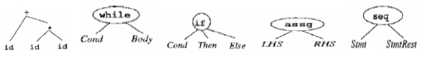

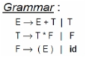

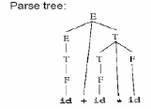

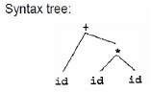

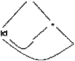

Example 2: DAG for the expression a + a * (b - c) + ( b - c ) * d is shown below.

Using the SDD to draw syntax tree or DAG for a given expression:-

·
·
·
Draw the parse tree
Perform a post order traversal of the parse tree
Perform the semantic actions at every node during the traversal

– Creates a syntax tree if a new node is created each time functions Leaf and
Node are called
– Constructs a DAG if before creating a new node, these functions check
whether an identical node already exists. If yes, the existing node is
returned.
SDD to produce Syntax trees or DAG is shown below.

For the expression a + a * ( b – c) + (b - c) * d, steps for constructing the DAG is as
below.

3

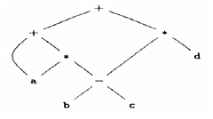

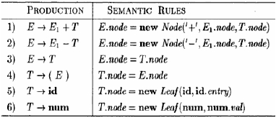

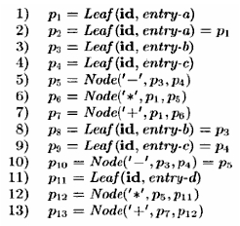

Value-Number Method for Constructing DAGs
Nodes of a syntax tree or DAG are stored in an array of records. The integer index of the
record for a node in the array is known as the value number of that node.

The signature of a node is a triple < op, l, r> where op is the label, l the value number of
its left child, and r the value number of its right child. The value-number method for
constructing the nodes of a DAG uses the signature of a node to check if a node with the
same signature already exists in the array. If yes, returns the value number. Otherwise,
creates a new node with the given signature.
Since searching an unordered array is slow, there are many better data structures to use.
Hash tables are a good choice.
Three Address Code(TAC)
TAC can range from high- to low-level, depending on the choice of operators. In general,
it is a statement containing at most 3 addresses or operands.
The general form is x := y op z, where “op” is an operator, x is the result, and y and z are
operands. x, y, z are variables, constants, or “temporaries”. A three-address instruction
consists of at most 3 addresses for each statement.
It is a linearized representation of a binary syntax tree. Explicit names correspond to
interior nodes of the graph. E.g. for a looping statement , syntax tree represents
components of the statement, whereas three-address code contains labels and jump
instructions to represent the flow-of-control as in machine language.

A TAC instruction has at most one operator on the RHS of an instruction; no built-up
arithmetic expressions are permitted.
e.g. x + y * z can be translated as
t1 = y * z
t2 = x + t1
where t1 & t2 are compiler–generated temporary names.

4

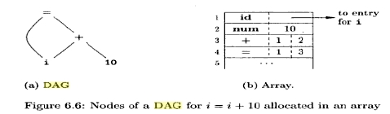

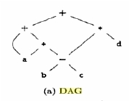

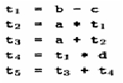

Since it unravels multi-operator arithmetic expressions and nested control-flow
statements, it is useful for target code generation and optimization.
Addresses and Instructions

·

·
TAC consists of a sequence of instructions, each instruction may have up to three
addresses, prototypically t1 = t2 op t3
Addresses may be one of:

–

–
–
A name. Each name is a symbol table index. For convenience, we write
the names as the identifier.
A constant.
A compiler-generated temporary. Each time a temporary address is
needed, the compiler generates another name from the stream t1, t2, t3,
etc.

·

·
Temporary names allow for code optimization to easily move
instructions
At target-code generation time, these names will be allocated to
registers or to memory.

·
TAC Instructions

–
Symbolic labels will be used by instructions that alter the flow of control.

The instruction addresses of labels will be filled
L: t1 = t2 op t3
in later.

–
Assignment instructions: x = y op z

·
Includes binary arithmetic and logical operations

–
Unary assignments: x = op y

·
Includes unary arithmetic op (-) and logical op (!) and type
conversion

–
–
Copy instructions:
Unconditional jump: goto L
x=y

·
L is a symbolic label of an instruction

–

–

–
Conditional jumps:
if x goto L If x is true, execute instruction L next
ifFalse x goto L If x is false, execute instruction L next
Conditional jumps:
if x relop y goto L
Procedure calls. For a procedure call p(x1, …, xn)
param x1
…
param xn
call p, n

–
Function calls : y= p(x1, …, xn)
y = call p,n , return y

5

–

Indexed copy instructions: x = y[i] and x[i] = y

·
·
Left: sets x to the value in the location i memory units beyond y
Right: sets the contents of the location i memory units beyond x to
y

–
Address and pointer instructions:

·
·

·
x = &y sets the value of x to be the location (address) of y.
x = *y, presumably y is a pointer or temporary whose value is a
location. The value of x is set to the contents of that location.
*x = y sets the value of the object pointed to by x to the value of y.

Example: Given the statement do i = i+1; while (a[i] < v ); , the TAC can be written as
below in two ways, using either symbolic labels or position number of instructions for
labels.

Three Address Code Representations
Data structures for representation of TAC can be objects or records with fields for
operator and operands. Representations include quadruples, triples and indirect triples.
Quadruples

·
In the quadruple representation, there are four fields for each instruction: op,
arg1, arg2, result

–
–
–
–
Binary ops have the obvious representation
Unary ops don’t use arg2
Operators like param don’t use either arg2 or result
Jumps put the target label into result

·
The quadruples in Fig (b) implement the three-address code in (a) for the

expression a = b * - c + b * - c

Triples

·
·
A triple has only three fields for each instruction: op, arg1, arg2
The result of an operation x op y is referred to by its position.

6

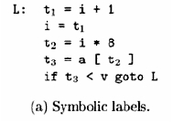

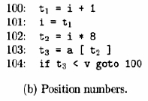

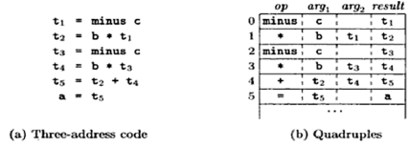

·
·

·

·

Triples are equivalent to signatures of nodes in DAG or syntax trees.
Triples and DAGs are equivalent representations only for expressions; they are
not equivalent for control flow.
Ternary operations like x[i] = y requires two entries in the triple structure,
similarly for x = y[i].
Moving around an instruction during optimization is a problem

Example: Representations of a =b *– c + b * – c

Indirect Triples
These consist of a listing of pointers to triples, rather than a listing of the triples
themselves. An optimizing compiler can move an instruction by reordering the
instruction list, without affecting the triples themselves.

Static Single-Assignment Form
Static single-assignment form (SSA) is an intermediate representation that facilitates
certain code optimizations. Two distinctive aspects distinguish SSA from three-address
code.

·

·
All assignments in SSA are to variables with distinct names; hence static single-
assignment.
Φ-FUNCTION
Same variable may be defined in two different control-flow paths. For
example,
if ( flag ) x = -1; else x = 1;
y = x * a;
using Φ-function it can be written as
if ( flag ) x1 = -1; else x2 = 1;
x3 = Φ(x1,x2);
y = x3 * a;

7

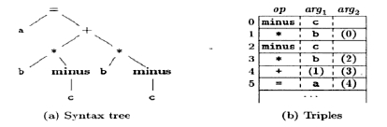

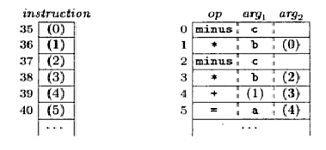

The Φ -function returns the value of its argument that corresponds to the control-
flow path that was taken to get to the assignment statement containing the Φ –
function.

Types
A type typically denotes a set of values and a set of operations allowed on those values.
Applications of types include type checking and translation.
Certain operations are legal for each type. For example, it doesn’t make sense to add a
function pointer and an integer in C. But it does make sense to add two integers. But both
have the same assembly language implementation!
A language’s Type System specifies which operations are valid for which types.
Type Checking is the process of verifying fully typed programs. Given an operation and
an operand of some type, it determines whether the operation is allowed. The goal of
type checking is to ensure that operations are used with the correct types. It uses logical
rules to reason about the behavior of a program and enforces intended interpretation of
values.
Type Inference is the process of filling in missing type information. Given the type of
operands, determine the meaning of the operation and the type of the operation; or,
without variable declarations, infer type from the way the variable is used.
Components of a Type System

·
·
·
·
Built-in types
Rules for constructing new types
Rules for determining if two types are equivalent
Rules for inferring the types of expressions

Type Expressions
Types have structure, represented using type expressions. Type expressions can be either
basic type or formed by applying type constructors.
Example: an array type int[2][3] has the type expression is array(2, array(3, integer))
where array is the operator and takes 2 parameters, a number and a type.
Definition of Type Expressions

·

·
·

·

·
A basic type is a type expression. Typical basic types for a language include
boolean, char, integer, float, and void.
A type name is a type expression.
A type expression can be formed by applying the array type constructor to a
number and a type expression.
A record is a data structure with named fields. A type expression can be formed
by applying the record type constructor to the field names and their types.
A type expression can be formed by using the type constructor → for function
types. We write s→ t for "function from type s to type t.

8

·

·

If s and t are type expressions, then their Cartesian product s × t is a type
expression. Products can be used to represent a list or tuple of types (e.g., for
function parameters).
Type expressions may contain variables whose values are type expressions.

Representing Type Expressions
Construct a DAG for type expression adapting the value-number method.
Interior nodes represent type constructors.
Leaves represent basic types, type names, and type variables.
Type graphs: are a graph-structured representation of type expressions:

–
–
–
Basic types are given predefined “internal values”;
Named types can be represented via pointers into a hash table.
A composite type expression f (T1,…,Tn) is represented as a node

identifying the constructor f and with pointers to the nodes for
T1, …,

Tn.
E.g.: type graph for the type expression of int x[10][20] is shown below.

Type Equivalence
The two types of type equivalence are structural equivalence and name equivalence.
Structural equivalence: When type expressions are represented by graphs, two
types are structurally equivalent if and only if one of the following conditions is
true:
1. They are the same basic type
2. They are formed by applying the same constructor to structurally
equivalent types.
3. One is a type name that denotes the other
Name equivalence: If type names are treated as standing for themselves, the first
two conditions above lead to name equivalence of type expressions.
Example 1: in the Pascal fragment
type p = ↑node;
q = ↑node;
var x : p;
y : q;
x and y are structurally equivalent, but not name-equivalent.

9
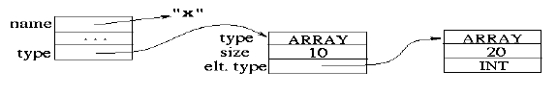

Example 2: Given the declarations
Type t1 = Array [1..10] of integer;
Type t2 = Array [1..10] of integer;

–
are they name equivalent? No because they have different type names.

Example 3: Given the declarations
type vector = array [1..10] of real
type weight = array [1..10] of real
var x, y: vector; z: weight
Name Equivalence: When they have the same name.

–
x, y have the same type; z has a different type.

Structural Equivalence: When they have the same structure.

–
x, y, z have the same type.

Translation Applications of Types
From the type of a name, we can determine the storage needed for the name at run time,
calculate the address denoted by an array reference, insert explicit type conversions, and
choose the right version of an arithmetic operator.
Types and storage layout for names are declared within a procedure or class. Actual
storage is allocated at run time. Type of a name can used to determine the amount of
storage needed for the name at run time. At compile time these amounts are used to
assign each name a relative address. Local declarations are examined and relative
addresses are laid out with respect to an offset from the start of a data area. The type and
relative address are saved in the symbol-table entry for the name. Pointer is assigned for
data for varying length like strings and dynamic arrays.
Declarations

The grammar
D →T id ; D | ε

T → B C | record ' { ' D '}'
B → int | float
C → ε |[num] C
declares just one name at a time; D- generates a sequence of declarations, T – generates
basic, array or record types, C – for ‘component’, generates strings of zero or more
integers , each integer surrounded by brackets.
SDT for computing types and their widths is as below.

10
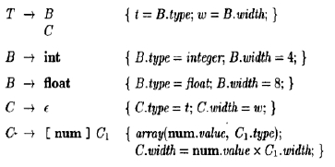

Syntax-directed translation of array types is shown in the dependency graph below for the
type declaration int [2][3].

Sequences of Declarations
The translation scheme below deals with a sequence of declarations of the form T id,
where T generates a type. Before the first declaration is considered, offset is set to 0. As
each new name x is seen, x is entered into the symbol table with its relative address set to
the current value of offset, which is then incremented by the width of the type of x.

The semantic action within the production D → T id ; D1 creates a symbol table entry by
executing top.put(id.lexeme, T.type, offset). Here top denotes the current symbol table.
The method top.put creates a symbol-table entry for id.lexeme, with type T.type and
relative address offset in its data area.
Fields in Records and Classes
Since records can essentially have a bunch of declarations inside, we only need add
T → RECORD { D } to get the syntax right. For the semantics we need to push the
environment and offset onto stacks since the namespace inside a record is distinct from
that on the outside. The width of the record itself is the final value of (the inner) offset.

T → record {
{ Env.push(top);
top = new Env();

Stack.push(offset); offset = 0; }

D }
{ T.type = record(top); T.width = offset;

top = Env.pop(); offset = Stack.pop(); }
Translation of Expressions
The goal is to generate 3-address code for expressions. Assume there is a function gen()
that given the pieces needed does the proper formatting so gen(x = y + z) will output the

11

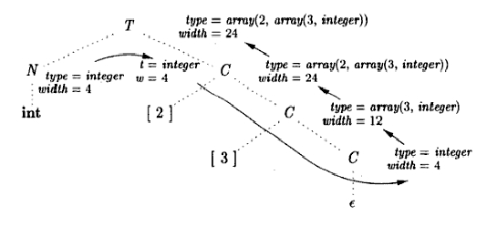

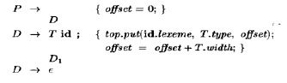

corresponding 3-address code. gen() is often called with addresses rather than lexemes
like x. The constructor Temp() produces a new address in whatever format gen needs.
Operations within Expressions
The syntax-directed definition below builds up the three-address code for an assignment
statement S using attribute code for S and attributes addr and code for an expression E.
Attributes S.code and E.code denote the three-address code for S and E, respectively.
Attribute E.addr denotes the address that will hold the value of E.

Incremental Translation
The method in the previous section generates long strings and we walk the tree. By using
SDT instead of using SDD, you can output parts of the string as each node is processed.

Addressing Array Elements
The idea is that you associate the base address with the array name. That is, the offset
stored in the identifier table is the address of the first element of the array. The indices
and the array bounds are used to compute the amount, often called the offset by which the
address of the referenced element differs from the base address.
One Dimensional Arrays
For one dimensional arrays, this is especially easy: The address increment is the width of
each element times the index (assuming indexes start at 0). So the address of A[i] is the
base address of A plus i times the width of each element of A.

12

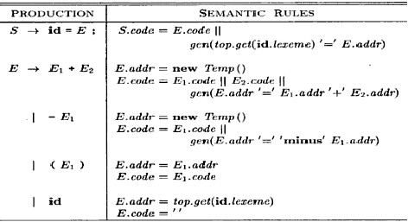

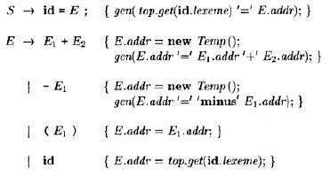

The width of each element is the width of what we have called the base type. base is the
relative address of the first location of array A, width is the width of each array element,
low is the index of the first array element. Then,

location of A[i]
base+(i-low)*width

Two Dimensional Arrays
Let us assume row major ordering. That is, the first element stored is A[0,0], then A[0,1],
... A[0,k-1], then A[1,0], ... . Modern languages use row major ordering.
With the alternative column major ordering, after A[0,0] comes A[1,0], A[2,0], ... .
For two dimensional arrays the address of A[i,j] is the sum of three terms
1. The base address of A.
2. The distance from A to the start of row i. This is i times the width of a row, which
is i times the number of elements in a row times the width of an element. The
number of elements in a row is the column array bound.
3. The distance from the start of row i to element A[i,j]. This is j times the width of
an element.
Grammar for Expressions With Array References

S → id = E;
|
L=E;

E → E1 + E2
|
id
|L

L → id [ E ]
|
L1 [ E ]

Generates expressions of the form a = b
a = b + c , a = b[i] , a[j]= c , a[j] = b[k] , a = b[c[i]], a[i]= b[i][j][k]
Nonterminal L has 3 synthesized attributes

·

·
L.addr – temporary that is used while computing the offset for the array reference
by summing the terms ij x wj
L.array is a pointer to the symbol table entry for the array name.

–
L.array.base is used to determine the actual l-value of an array reference
after all the index expressions are analyzed.

·
L.type - type of the subarray generated by L .

–
For an array type t , t.elem gives the element type

The SDT for translating array references is as below.

13

An annotated parse tree for the expression c + a [ i ] [ j ] is shown in figure below. The
expression is translated into the sequence of three-address instructions as shown.

Type Checking

Type Checking includes several aspects.

1. The language comes with a type system, i.e., a set of rules saying what types can
appear where.
2. The compiler assigns a type expression to parts of the source program.
3. The compiler checks that the type usage in the program conforms to the type
system for the language.

14

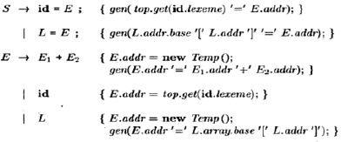

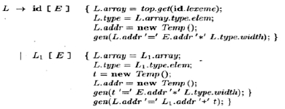

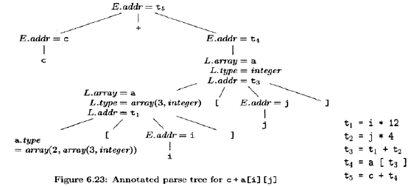

A sound type system guarantees that all checks can be performed prior to execution. This
does not mean that a given compiler will make all the necessary checks.

An implementation is strongly typed if compiled programs are guaranteed to run without
type errors.

Rules for Type Checking

There are two forms of type checking.

1. type synthesis where the types of parts are used to infer the type of the whole. For
example, integer+real=real. Synthesis computes the type of an expression using
its sub-expressions and requires names to be declared before they are used.

Typical rule for type synthesis:

if f has type s → t and x has type s,
then expression f(x) has type t

2. Type inference where the type of a construct is determined from usage. This
permits languages like ML to check types even though names need not be
declared.

Typical rule for type synthesis

if f(x) is an expression,
then for some α and β, f has type has type α → β and x has type β

Type Conversions

A very strict type system would do no automatic conversion. Instead it would offer
functions for the programmer to explicitly convert between selected types. Then either
the program has compatible types or is in error.

However, we will consider a more liberal approach in which the language permits certain
implicit conversions that the compiler is to supply. This is called type
coercion. Explicit conversions supplied by the programmer are
called casts.

Consider the more general case where there are multiple types some of
which have coercions (often called widening). For example in C/Java, int
can be widened to long, which in turn can be widened to float as shown in
the figure to the right.

Semantic Action For Checking E →E1 + E2
Two functions, max and widen are used.

15

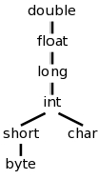

1. max(t1,t2)

–

–
takes two types t1 and t2 and returns the maximum (or least upper bound)
of the two types in the widening hierarchy.
declares an error if either t1 or t2 is not in the hierarchy; e.g., if either type
is an array or a pointer type.

2.
widen(a, t, w)

–

–
–
generates type conversions if needed to widen an address a of type t into a
value of type w.
It returns a itself if t and w are the same type.
Otherwise, it generates an instruction to do the conversion and place the

result in a temporary t, which is returned as the result.
Pseudocode for Function widen
Addr widen(Addr a, Type t, Type w)
if ( t = w ) return a;
else if ( t = integer and w = float) {
temp = new Temp();
gen(temp '=' '(float)' a);
return temp;
}
else error;
}
Introducing Type Conversions into Expression Evaluation
E → E1 + E2 { E.type = max(E1.type, E2.type);
a1= widen(E1. addr, E1. type, E. type);
a2 = widen(E2. addr, E2 .type, E. type);
E. Addr = new Temp ();
gen(E.addr ‘=‘ a1 '+' a2); }

Overloading of Functions and Operators
An overloaded symbol has different meanings depending on its context. Overloading is
resolved when a unique meaning is determined for each occurrence of a name.
Overloading in Java can be resolved by looking only at the arguments of a function. The
+ operator in Java denotes either string concatenation or addition, depending on the types
of its operands.
Type-Synthesis Rule for Overloaded Functions

If f can have type si → ti, for 1 ≤ i ≤ n, where si ≠sj
for i ≠ j

16

and x has type sk, for some 1 ≤ k ≤ n
then expression f(x) has type tk
The value-number method can be applied to type expressions to resolve overloading
based on argument types, efficiently. Since the signature for a function consists of the
function name and the types of its arguments, overloading can be resolved based on
signatures. However, it is not always possible to resolve overloading by looking only at
the arguments of a function.
Type Inference and Polymorphic Functions
The term "polymorphic" refers to any code fragment that can be executed with arguments
of different types. In parametric polymorphism, the polymorphism is characterized by
parameters or type variables.
Example: ML program for the length of a list is defined as
fun length(x) =if null(x) then 0 else length(tl(x)) +1;
Here function length determines the length or number of elements of a list x, predefined
function null tests whether a list is empty, and function tl (short for "tail") returns the
remainder of a list after the first element is removed.
All elements of a list must have the same type, but length can be applied to lists whose
elements are of any one type.
Example:
length([“sun”, “mon”, “tue”]) + length([10,9,8,7])
Type of length :
α.list (α)→ integer

A type expression with a
symbol in it is referred to informally as a "polymorphic

type."
symbol is the universal quantifier. A type variable to which it is applied is

said to be bound by it. Bound variables can be renamed at will, provided all occurrences
of the variable are renamed. Each time a polymorphic function is applied, its bound type
variables can denote a different type.
During type checking, at each use of a polymorphic type we replace the bound variables
by fresh variables and remove the universal quantifiers.
We can infer a type for length using the type inference rule
if f(x) is an expression,
then for some α and β, f has type α →β and x has type α
Abstract syntax tree for the length function definition

17

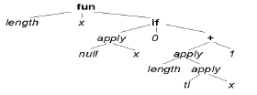

Substitution
A substitution is a mapping from type variables to type expressions. The result of
applying the substitution S to the variables in type expression t is denoted S(t). All
occurrences of each type variable α in t is replaced by S(α). S(t) is called an instance
of t.
Example: list(integer) is an instance of list(α).
Equivalence of Types
Two type expressions t1 and t2 unify if there exists some substitution S such that S(t1) =
S(t2).
Suppose E1 of type s →s' is applied to E2 of type t.
Unification: the problem of determining whether two expressions s and t can be made
identical by substituting expressions for the variables in s and t.
Testing equality of expressions is a special case of unification
If s and t have constants but no variables, then s and t unify if and only if they are
identical.
Most general unifier is a substitution that imposes the fewest constraints on the variables
in the expressions.
Type Inference for Polymorphic Functions
INPUT: A program consisting of a sequence of function definitions followed by an
expression to be evaluated. An expression is made up of function applications and names,
where names can have predefined polymorphic types.
OUTPUT: Inferred types for the names in the program.
METHOD: The type of a function f(x1,x2) with two parameters can be represented by a
type expression s1 x s2 → t, where s1 and s2 are the types of x1 and x2, respectively, and
t is the type of the result f(x1,x2).
An expression f (a, b) can be checked by matching the type of a with s1 and the type of
b with s2. We first check the function definitions and the expression in the input sequence
and then use the inferred type of a function if it is subsequently used in an expression.
For a function definition fun id1(id2) = E

·
·

·
create fresh type variables α and β.
Associate the type α→β with the function id1 and the type α with the parameter
id2.
Infer a type for expression E. Suppose α denotes type s and β denotes type t after
type inference for E. The inferred type of function id1 is s → t.

·
Bind any type variables that remain unconstrained in
s → t by universal

quantifiers.
For a function application E1(E2 )

18

·

·
·

infer types for E1 and E2. Since E1 is used as a function, its type must have the
form s → s'. Let t be the inferred type of E1.
Unify s and t.
If unification fails, the expression has a type error. Otherwise, the inferred type of

E1(E2) is s'.
For each occurrence of a polymorphic function

·

·
replace the bound variables in its type by distinct fresh variables and remove the
quantifiers.
The resulting type expression is the inferred type of this occurrence.

For a name that is encountered for the first time

·
introduce a fresh variable for its type.

Using the above rules , a type for function length can be inferred as
α.list (α)→ integer . The steps are as in the table below.

Graph-Theoretic Formulation Of Unification
In this scheme, types are represented by graphs. Type variables are represented by leaves
and type constructors are represented by interior nodes.
Nodes are grouped into equivalence classes; if two nodes are in the same equivalence
class, then the type expressions they represent must unify.
Thus, all interior nodes in the same class must be for the same type constructor, and their
corresponding children must be equivalent.
ALGORITHM: Unification of a pair of nodes in a type graph.
INPUT: A graph representing a type and a pair of nodes m and n to be unified.

19
LINE | EXPRESSION : TYPE | UNIFY
1) | length: β→γ
2) | x: β
3) | if : boolean × αi × αi → αi
4) | null : list (αn) → boolean
5) | null(x) : boolean | list (αn) = β
6) | 0: integer | αi = integer
7) | + : integer × integer → integer
8) | tl : list(αt) → list(αt)
9) | tl(x) : list(αt) | list(αt) = list(αn)
10) | length(tl(x) ) : γ | γ = integer

OUTPUT: Boolean value true if the expressions represented by the nodes m and n unify;
false, otherwise.
METHOD: A node is implemented by a record with fields for a binary operator and
pointers to the left and right children. The sets of equivalent nodes are maintained using
the set field. One node in each equivalence class is chosen to be the unique
representative of the equivalence class by making its set field contains a null pointer. The
set fields of the remaining nodes in the equivalence class will point (possibly indirectly
through other nodes in the set) to the representative. Initially, each node n is in an
equivalence class by itself, with n as its own representative node.
Unification algorithm uses two operations find(n) and union(m,n) on nodes.

·

·
–
find(n) returns the representative node of the equivalence class currently
containing node n.
union(m, n) merges the equivalence classes containing nodes m and n.
The union operation on sets is implemented by simply changing the set field of

the representative of one equivalence class so that it points to the representative of
the other.
To find the equivalence class that a node belongs to, we follow the set pointers of nodes
until the representative (the node with a null pointer in the set field) is reached
Unification Algorithm
boolean unify(Node m, Node n) {
s = find(m); t = find(n);
if ( s — t ) return true;
else if ( nodes s and t represent the same basic type ) return true;
else if (s is an op-node with children s1 and s2 and
t is an op-node with children t1 and t2) {
union(s, t);
return unify(s1,t1) and unify(s2,t2);
}
else if s or t represents a variable {
union(s,t);
return true;
}
else return false;
}

20

Control Flow

Control flow includes the study of Boolean expressions, which have two roles.

1. They can be computed and treated similar to integers or real. Once can declare
Boolean variables, there are boolean constants and boolean operators. There are
also relational operators that produce Boolean values from arithmetic operands.
2. They are used in certain statements that alter the normal flow of control.

Boolean Expressions
One question that comes up with Boolean expressions is whether both operands need be
evaluated. If we need to evaluate A OR B and find that A is true, must we evaluate B?
For example, consider evaluating A=0 OR 3/A < 1.2 when A is zero.
This comes up some times in arithmetic as well. Consider A*F(x). If the compiler knows
that for this run A is zero must it evaluate F(x)? Functions can have side effects, do it
could be a potential problem .
Short-Circuit Code
This is also called jumping code. Here the Boolean operators AND, OR, and NOT do not
appear in the generated instruction stream. Instead we just generate jumps to either the
true branch or the false branch.
Example:
if ( x < 100 II x > 200 && x != y ) x = 0;
if x < 100 goto L2
if False x > 200 goto L1
if False x != y goto L1
L2: x = 0
L1:
Flow-of-Control Statements

The grammar is (S for statement, B for boolean expression)

S → if ( B ) S1

S → if ( B ) S1 else S2

S → while ( B ) S1

21

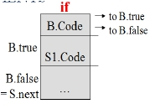

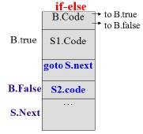

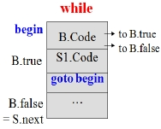

If and while SDDs

Production

P → S

S → if ( B ) S1

Semantic Rules

S.next = newlabel()
P.code = S.code || label(S.next)

B.true = newlabel()
B.false = S.next
S1.next = S.next

Kind

Inherited
Synthesized

Inherited
Inherited
Inherited

S.code = B.code || label(B.true) || S1.code

B.true = newlabel()
B.false = newlabel()
S → if ( B ) S1 else S1.next = S.next
Synthesized

Inherited
Inherited
Inherited

S2

S → while ( B ) S1

S → S1 S2
S2.next = S.next
S.code = B.code || label(B.true) || S1.code
|| gen(goto S.next) || label(B.false) || S2.code

begin = newlabel()
B.true = newlabel()
B.false = S.next
S1.next = begin
S.code = label(begin) || B.code || label(B.true) ||
S1.code || gen(goto begin)

S1.next = newlabel()
S2.next = S.next
S.code = S1.code || label(S1.next) || S2.code
Inherited

Synthesized

Synthesized
Inherited
Inherited
Inherited

Synthesized

Inherited
Inherited
Synthesized

Control-Flow Translation of Boolean Expressions
SDD for Boolean Expressions is shown below.

Production Semantic Rules

B1.true = B.true
Kind

Inherited

B → B1 || B2
B1.false = newlabel()
B2.true = B.true
Inherited
Inherited

22

B2.false = B.false
B.code = B1.code || label(B1.false) || B2.code

B1.true = newlabel()
B1.false = B.false
B → B1 && B2 B2.true = B.true
B2.false = B.false
B.code = B1.code || label(B1.true) || B2.code

B1.true = B.false

Inherited
Synthesized

inherited
inherited
inherited
inherited
Synthesized

Inherited

B → ! B1
B1.false = B.true
B.code = B1.code

B.code = E1.code || E2.code
Inherited
Synthesized

B → E1 relop E2
|| gen(if E1.addr relop.lexeme E2.addr goto B.true) Synthesized
|| gen(goto B.false)

B → true

B → false

B → ID

The translation of

B.code = gen(goto B.true)

B.code = gen(goto B.false)

B.code = gen(if get(ID.lexeme) goto B.true)
|| gen(goto B.false)

if ( x < 5 || x > 10 && x == y ) x = 3 ;

Synthesized

Synthesized

Synthesized

if x < 5 goto L2
goto L3
L3: if x > 10 goto L4
goto L1
L4: if x == y goto L2
goto L1
L2: x = 3
Note that there are three extra gotos. One is a goto the next statement. Two others could
be eliminated by using ifFalse.

23

Avoiding Redundant Gotos
x > 200 translates into the code fragment:
if x > 200 goto L4
goto L1
L4 : ···
Instead, consider the instruction:
if Falsex > 200 goto L1
L4 : ···
ifFalse instruction takes advantage of the natural flow from one instruction to the next in
sequence, so control simply "falls through" to label L4 if x > 200 is false, thereby
avoiding a jump.

Rewriting Using fall Label

S →if ( B ) S1

B.True = fall

B.False = S1.next = S.next
S.Code = B.code || S1.code

Semantic rules for B → E1 rel E2
test = E1.addr rel.op E2.addr
s = if B.true ≠ fall and B.false ≠ fall then
gen(‘if' test 'goto' B.true) || gen('goto' B.false)
else if B.true ≠ fall then gen(‘if' test 'goto' B.true)
else if B.false ≠ fall then gen('ifFalse' test 'goto' B.false)
else ''
B.code = E1.code || E2.code || s

Semantic rules for B → B1 || B2
B1.true = if B.true ≠ fall then B.true else newlabel()
B1. false = fall
B2.true = B.true
B2. false = B.false
B.code = if B.true ≠ fall then B1.code || B2.code
else B1.code || B2.code || label(B1.true)

24

Using the above rules if ( x < 100 || x > 200 && x != y ) x = 0; translates to

if x < 100 goto L2
ifFalse x > 200 goto L2
ifFalse x != y goto L1
L2 : x = 0
L1 :

Boolean Values and Jumping Code
First build a syntax tree for expressions, using either of the following approaches:
1. Use two passes: Construct a complete syntax tree for the input, and then walk the tree
in depth-first order, computing the translations specified by the semantic rules.
2. Use one pass for statements, but two passes for expressions: translate E in while (E)
S1 before S1 is examined.
The following grammar has a single nonterminal E for expressions:
S →id = E ; | if ( E ) S | while (E)S | S S
E → E || E | E&&E | E rel E | E + E | (E) | id | true | false
E.n represents syntax tree node for E. Two methods jump and rvalue are used in
evaluating expressions.
jump – method to generate jumping code at an expression node

–
When E appears in S → while (E) S1 , call E.n.jump(t, f), where t is a new

label for the first instruction of S1.code and f is the label S.next.
rvalue – method to generate code to compute the value of the node into a temporary.

–
–
–
When E appears in S → id = E; , method rvalue is called at node E.n.
1. E has form of E → E1 + E2 , call E.n.rvalue()
2. E has form of E → E1 && E2, generate jumping code for E and then assign

true or false to a new temporary t at the true and false exits, respectively, from the
jumping code.
Backpatching
A key problem when generating code for boolean expressions and flow-of-control
statements is that of matching a jump instruction with the target of the jump. For
example, the translation of the boolean expression B in if ( B ) S contains a jump, for
when B is false, to the instruction following the code for S. In a one-pass translation, B
must be translated before S is examined. Labels can be passed as inherited attributes to
where the relevant jump instructions were generated. But a separate pass is then needed
to bind labels to addresses.

In backpatching, lists of jumps are passed as synthesized attributes. Specifically, when a
jump is generated, the target of the jump is temporarily left unspecified. Each such jump

25

is put on a list of jumps whose labels are to be filled in when the proper label can be
determined. All of the jumps on a list have the same target label.

One-Pass Code Generation Using Backpatching
Backpatching can be used to generate code for boolean expressions and flow-of-control
statements in one pass.
Synthesized attributes truelist and falselist of nonterminal B are used to manage labels in
jumping code for boolean expressions. B. truelist will be a list of jump or conditional
jump instructions into which we must insert the label to which control goes if B is true.
B.falselist likewise is the list of instructions that eventually get the label to which control
goes when B is false. As code is generated for B, jumps to the true and false exits are left
incomplete, with the label field unfilled. These incomplete jumps are placed on lists
pointed to by B.truelist and B.falselist, as appropriate.
A statement S has a synthesized attribute S.nextlist, denoting a list of jumps to the
instruction immediately following the code for S.
Instructions are generated into an instruction array, and labels will be indices into this
array.
To manipulate lists of jumps, we use three functions: makelist(i), merge(p1,p2),
backpatch(p,i)

·

·

·
makelist(i) creates a new list containing only i, an index into the array of
instructions; makelist returns a pointer to the newly created list.
merge(p1,p2) concatenates the lists pointed to by p1 and p2, and returns a pointer
to the concatenated list.
backpatch(p,i) inserts i as the target label for each of the instructions on the list

pointed to by p.
Backpatching for Boolean Expressions

B → B1 || M B2 | B1 && M B2 | ! B | ( B ) | E1 rel E2 | true | false

M →ε

·

A marker nonterminal M in the grammar causes a semantic action to pick up, at
appropriate times, the index of the next instruction to be generated.

Translation Scheme for Boolean Expressions

B → B1 || M B2

B → B1 && M B2
{ backpatch(B1.falselist, M.instr);
B.truelist = merge(B1. truelist, B2.truelist);
B.falselist = B2.falselist; }

{ backpatch(B1.truelist, M.instr);
B.truelist = B2.truelist;
B.falselist = merge(B1.falselist,B2.falselist); }

26

B → ! B1

B → ( B1 )

B → E1 rel E2

B → true

B → false

M → ε

{ B.truelist = B1.falselist;
B.falselist = Bi.truelist; }
{ B.truelist = B1.truelist;
B.falselist = B1.falselist; }
{ B.truelist = makelist(nextinstr);
B.falselist = makelist(nextinstr + 1);
emit(‘if' E1.addr rel.op E2.addr 'goto _');
emit('goto _'); }

{ B.truelist = makelist(nextinstr); emit('goto _'); }

{ B.falselist = makelist(nextinstr); emit('goto _'); }

{ M.instr = nextinstr, }

Applying the above SDT to the statement if ( x < 100 II x > 200 && x != y ) x = 0;
gives a annotated parse tree as below.

Backpatching for Flow-Of-Control Statements

The grammar is given by the following productions :

S → if (B) S | if (B) S else S | while (B) S
|{L}|A;
L → LS |S

Where S – statement
L – list of statements
A- assignment statement
B – boolean expression

27

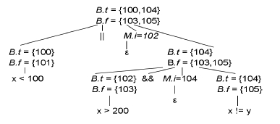

Translation of flow-of-control Statements Using Backpatching

S →if (B) M S1
{ backpatch{B.truelist, M.instr);
S.nextlist = merge(B.falselist, S1.nextlist); }
S → if (B) M1 S1 N else M2 S2
{ backpatch(B .truelist, M1.instr);
backpatch(B .falselist, M2.instr);
temp = merge(S1.nextlist, N.nextlist);
S.nextlist = merge(temp, S2.nextlist); }
S → while M1 (B) M2 S1
{ backpatch(S1.nextlist, M1.instr);
backpatch(B. truelist, M2.instr);
S.nextlist = B. falselist;
emit('goto' M1.instr); }

S → {L}

S →A ;
M →ε
{ S.nextlist = L.nextlist; }

{ S.nextlist = null; }
{ M.instr = nextinstr; }

S → {L}
{ N.nextlist = makelist(nextinstr);
emit('goto _'); }
L → L1 M S
{ backpatch(L1.nextlist, M.instr)
L. Nextlist = S. nextlist; }

L → S
{ L. nextlist — S. nextlist; }

Switch Statements
Consider a mulit-way branching statement with C-like syntax:

switch (E) {
case V [1]: S[1]
·· · ·
case V [k]: S[k]
default: S[d]
}

Translation sequence:
· Evaluate the expression.
· Find which value in the list matches the value of the expression, match default only if
there is no match.
· Execute the statement associated with the matched value. The matched value can be
found by Sequential test, Look-up table or Hash table.

Implementation of case statements: Use a table and a loop to find the address to jump.

28


When there are more than 10 entries, use a hash table to find the correct table entry.

Back-patching: We generate a series of branching statements with the targets of the
jumps temporarily left unspecified. Use a to-be-determined label table, each entry of
which contains a list of places that need to be back-patched. The same table can also be
used to implement labels and goto’s.

There are two possible ways to translate switch statements.
Scheme 1:
code to evaluate E into t
goto test
L[1]: code for S[1]
goto next
...
L[k]: code for S[k]
goto next
L[d]: code for S[d]
goto next
test:
if t = V[1] goto L[1]
...
if t = V[k] goto L[k]
goto L[d]
next:
...
Scheme 2:
code to evaluate E into t
if t <> V[1] goto L[1]
code for S[1]
goto next
L[1]: if t <> V[2] goto L[2]
code for S[2]
goto next
...
L[k-1]: if t <> V[k] goto
L[k]
code for S[k]
goto next
L[k]: code for S[d]
next:

The first scheme is simpler to implement as it creates all the necessary labels first and
then goes for test and branching.

Case three-address-code instructions used to translate a switch statement are as below.
case t V1 L1

29

case t V2 L2
...
case t Vn-1 Ln-1
case t t Ln
label next

Intermediate Code for Procedures
Assume that parameters are passed by value. Suppose that a is an array of integers,
and that f is a function from integers to integers. Then, the assignment n = f ( a [ i ] ) ;
might translate into the following three-address code:
1. t 1 = i * 4
2. t 2 = a [ t 1 ]
3. param t2
4. t3 = call f, 1
5. n = t 3

The grammar below adds functions to the source language
D → define T id ( F ) { S }
F → ε | T id , F
S → return E ;
E → id ( A )
A →ε |E,A

30

